**Day 5 - mdmoindn 201934371 (Mohammad Moinuddin)**

**Task1-4:**

Administrator@a0537ae3a1875ee MINGW64 /d/Atlas-D5/Linux Practice

$ touch TestFile2.txt

Administrator@a0537ae3a1875ee MINGW64 /d/Atlas-D5/Linux Practice

$ echo "This is a sample file for adding content in file 2 for practise" > TestFile2.txt

Administrator@a0537ae3a1875ee MINGW64 /d/Atlas-D5/Linux Practice

$ mkdir Dummy

Administrator@a0537ae3a1875ee MINGW64 /d/Atlas-D5/Linux Practice

$ ls -1

Dummy/

TestFile1.txt

TestFile2.txt

Administrator@a0537ae3a1875ee MINGW64 /d/Atlas-D5/Linux Practice

$ cd Dummy/

Administrator@a0537ae3a1875ee MINGW64 /d/Atlas-D5/Linux Practice/Dummy

$

Administrator@a0537ae3a1875ee MINGW64 /d/Atlas-D5

$ cd Linux\ Practice/

Administrator@a0537ae3a1875ee MINGW64 /d/Atlas-D5/Linux Practice

$ rm -r Dummy

**Task 6:**

Administrator@a0537ae3a1875ee MINGW64 /d/Atlas-D5/Linux Practice

$ ls -l

Administrator@a0537ae3a1875ee MINGW64 /d/Atlas-D5/Linux Practice

$ ls -l

total 6

drwxr-xr-x 1 Administrator 197121 0 May 30 16:32 Dir1/

drwxr-xr-x 1 Administrator 197121 0 May 30 16:33 Dir2/

drwxr-xr-x 1 Administrator 197121 0 May 30 16:33 Dir3/

-rw-r--r-- 1 Administrator 197121 575 May 30 16:42 DummyText.txt

-rw-r--r-- 1 Administrator 197121 59 May 30 17:35 TestFile6.txt

-rw-r--r-- 1 Administrator 197121 28 May 30 17:37 TestFile7

-rw-r--r-- 1 Administrator 197121 60 May 30 17:38 TestFile8.txt

-rw-r--r-- 1 Administrator 197121 25 May 30 17:41 file_cat.txt

-rw-r--r-- 1 Administrator 197121 6 May 30 17:41 file_echo.txt

-rw-r--r-- 1 Administrator 197121 0 May 30 17:41 file_touch.txt

Administrator@a0537ae3a1875ee MINGW64 /d/Atlas-D5/Linux Practice

$ touch TestFile{3..6}.txt

Administrator@a0537ae3a1875ee MINGW64 /d/Atlas-D5/Linux Practice

$ ls -1

TestFile1.txt

TestFile2.txt

TestFile3.txt

TestFile4.txt

TestFile5.txt

TestFile6.txt

Administrator@a0537ae3a1875ee MINGW64 /d/Atlas-D5/Linux Practice

$ ls -1

TestFile1.txt

TestFile2.txt

TestFile3.txt

TestFile4.txt

TestFile5.txt

TestFile6.txt

Administrator@a0537ae3a1875ee MINGW64 /d/Atlas-D5/Linux Practice

$ ls -l

total 2

-rw-r--r-- 1 Administrator 197121 32 May 30 15:55 TestFile1.txt

-rw-r--r-- 1 Administrator 197121 64 May 30 16:04 TestFile2.txt

-rw-r--r-- 1 Administrator 197121 0 May 30 16:16 TestFile3.txt

-rw-r--r-- 1 Administrator 197121 0 May 30 16:16 TestFile4.txt

-rw-r--r-- 1 Administrator 197121 0 May 30 16:16 TestFile5.txt

-rw-r--r-- 1 Administrator 197121 0 May 30 16:16 TestFile6.txt

**Task 7-9:**

Administrator@a0537ae3a1875ee MINGW64 /d/Atlas-D5/Linux Practice

$ mkdir Dir1 Dir2 Dir3

Administrator@a0537ae3a1875ee MINGW64 /d/Atlas-D5/Linux Practice

$ mv TestFile{1..6}.txt Dir1/

Administrator@a0537ae3a1875ee MINGW64 /d/Atlas-D5/Linux Practice

$ cp Dir1/* Dir2/

Administrator@a0537ae3a1875ee MINGW64 /d/Atlas-D5/Linux Practice

$ mv Dir2/* Dir3/

**Task 10:** DIFFERENCE BETWEEN between **rm** and **rmdir**

Administrator@a0537ae3a1875ee MINGW64 /d/Atlas-D5/Linux Practice

$ mkdir Dir1 Dir2 Dir3

Administrator@a0537ae3a1875ee MINGW64 /d/Atlas-D5/Linux Practice

$ mv TestFile{1..6}.txt Dir1/

Administrator@a0537ae3a1875ee MINGW64 /d/Atlas-D5/Linux Practice

$ cp Dir1/* Dir2/

Administrator@a0537ae3a1875ee MINGW64 /d/Atlas-D5/Linux Practice

$ mv Dir2/* Dir3/

Administrator@a0537ae3a1875ee MINGW64 /d/Atlas-D5/Linux Practice

$ mkdir demo_dir demo_dir_nonempty

Administrator@a0537ae3a1875ee MINGW64 /d/Atlas-D5/Linux Practice

$ touch demo_dir_nonempty/file.txt

Administrator@a0537ae3a1875ee MINGW64 /d/Atlas-D5/Linux Practice

$ rmdir demo_dir

Administrator@a0537ae3a1875ee MINGW64 /d/Atlas-D5/Linux Practice

$ rmdir demo_dir_nonempty

rmdir: failed to remove 'demo_dir_nonempty': Directory not empty

Administrator@a0537ae3a1875ee MINGW64 /d/Atlas-D5/Linux Practice

$ rm -r demo_dir_nonempty

**Task 11:** USING CAT COMMAND AND CREATING FILE

Administrator@a0537ae3a1875ee MINGW64 /d/Atlas-D5/Linux Practice

$ cat > DummyText.txt

Lorem Ipsum is simply dummy text of the printing and typesetting industry. Lorem Ipsum has been the industry's standard dummy text ever since the 1500s, when an unknown printer took a galley of type and scrambled it to make a type specimen book. It has survived not only five centuries, but also the leap into electronic typesetting, remaining essentially unchanged. It was popularised in the 1960s with the release of Letraset sheets containing Lorem Ipsum passages, and more recently with desktop publishing software like Aldus PageMaker including versions of Lorem Ipsum.

Administrator@a0537ae3a1875ee MINGW64 /d/Atlas-D5/Linux Practice

$ cat DummyText.txt

Lorem Ipsum is simply dummy text of the printing and typesetting industry. Lorem Ipsum has been the industry's standard dummy text ever since the 1500s, when an unknown printer took a galley of type and scrambled it to make a type specimen book. It has survived not only five centuries, but also the leap into electronic typesetting, remaining essentially unchanged. It was popularised in the 1960s with the release of Letraset sheets containing Lorem Ipsum passages, and more recently with desktop publishing software like Aldus PageMaker including versions of Lorem Ipsum.

**Task 12-14:**

Administrator@a0537ae3a1875ee MINGW64 /d/Atlas-D5/Linux Practice

$ head DummyText.txt

Lorem Ipsum is simply dummy text of the printing and typesetting industry. Lorem Ipsum has been the industry's standard dummy text ever since the 1500s, when an unknown printer took a galley of type and scrambled it to make a type specimen book. It has survived not only five centuries, but also the leap into electronic typesetting, remaining essentially unchanged. It was popularised in the 1960s with the release of Letraset sheets containing Lorem Ipsum passages, and more recently with desktop publishing software like Aldus PageMaker including versions of Lorem Ipsum.

Administrator@a0537ae3a1875ee MINGW64 /d/Atlas-D5/Linux Practice

$ head -n 5 DummyText.txt

Lorem Ipsum is simply dummy text of the printing and typesetting industry. Lorem Ipsum has been the industry's standard dummy text ever since the 1500s, when an unknown printer took a galley of type and scrambled it to make a type specimen book. It has survived not only five centuries, but also the leap into electronic typesetting, remaining essentially unchanged. It was popularised in the 1960s with the release of Letraset sheets containing Lorem Ipsum passages, and more recently with desktop publishing software like Aldus PageMaker including versions of Lorem Ipsum.

Administrator@a0537ae3a1875ee MINGW64 /d/Atlas-D5/Linux Practice

$ head -n 5 DummyText.txt

Lorem Ipsum is simply dummy text of the printing and typesetting industry. Lorem Ipsum has been the industry's standard dummy text ever since the 1500s, when an unknown printer took a galley of type and scrambled it to make a type specimen book. It has survived not only five centuries, but also the leap into electronic typesetting, remaining essentially unchanged. It was popularised in the 1960s with the release of Letraset sheets containing Lorem Ipsum passages, and more recently with desktop publishing software like Aldus PageMaker including versions of Lorem Ipsum.

Administrator@a0537ae3a1875ee MINGW64 /d/Atlas-D5/Linux Practice

$ Administrator@a0537ae3a1875ee MINGW64 /d/Atlas-D5/Linux Practice

$ cat > DummyText.txt

Lorem Ipsum is simply dummy text of the printing and typesetting industry. Lorem Ipsum has been the industry's standard dummy text ever since the 1500s, when an unknown printer took a galley of type and scrambled it to make a type specimen book. It has survived not only five centuries, but also the leap into electronic typesetting, remaining essentially unchanged. It was popularised in the 1960s with the release of Letraset sheets containing Lorem Ipsum passages, and more recently with desktop publishing software like Aldus PageMaker including versions of Lorem Ipsum.

Administrator@a0537ae3a1875ee MINGW64 /d/Atlas-D5/Linux Practice

$ cat DummyText.txt

Lorem Ipsum is simply dummy text of the printing and typesetting industry. Lorem Ipsum has been the industry's standard dummy text ever since the 1500s, when an unknown printer took a galley of type and scrambled it to make a type specimen book. It has survived not only five centuries, but also the leap into electronic typesetting, remaining essentially unchanged. It was popularized in the 1960s with the release of Letraset sheets containing Lorem Ipsum passages, and more recently with desktop palisade

**TASK 15 :**

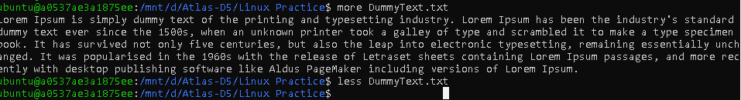

**What is e in echo command..?**

Administrator@a0537ae3a1875ee MINGW64 /d/Atlas-D5/Linux Practice

$ echo "Hello\nWorld"

Hello\nWorld

Administrator@a0537ae3a1875ee MINGW64 /d/Atlas-D5/Linux Practice

$ echo -e "Hello\nWorld"

Hello

World

TASK 17 :

Administrator@a0537ae3a1875ee MINGW64 /d/Atlas-D5/Linux Practice

$ ls

Dir1/ Dir2/ Dir3/ DummyText.txt TestFile6.txt TestFile7 TestFile8.txt file_cat.txt file_echo.txt file_touch.txt

Administrator@a0537ae3a1875ee MINGW64 /d/Atlas-D5/Linux Practice

$ ls -l

total 6

drwxr-xr-x 1 Administrator 197121 0 May 30 16:32 Dir1/

drwxr-xr-x 1 Administrator 197121 0 May 30 16:33 Dir2/

drwxr-xr-x 1 Administrator 197121 0 May 30 16:33 Dir3/

-rw-r--r-- 1 Administrator 197121 575 May 30 16:42 DummyText.txt

-rw-r--r-- 1 Administrator 197121 59 May 30 17:35 TestFile6.txt

-rw-r--r-- 1 Administrator 197121 28 May 30 17:37 TestFile7

-rw-r--r-- 1 Administrator 197121 60 May 30 17:38 TestFile8.txt

-rw-r--r-- 1 Administrator 197121 25 May 30 17:41 file_cat.txt

-rw-r--r-- 1 Administrator 197121 6 May 30 17:41 file_echo.txt

-rw-r--r-- 1 Administrator 197121 0 May 30 17:41 file_touch.txt

Ls

|  |
| --- |
|  |

|  |
| --- |
| Lists files and directories in **short form** (names only) |

Ls -l :

|  |
| --- |
|  |

|  |
| --- |
| Lists files and directories in **long format**, showing detailed info such as permissions, owner, size, and modification time |

**Task 18:**

Administrator@a0537ae3a1875ee MINGW64 /d/Atlas-D5/Linux Practice

$ cat > TestFile7

Hello this is a sample file

Administrator@a0537ae3a1875ee MINGW64 /d/Atlas-D5/Linux Practice

$ cat TestFile7.txt

cat: TestFile7.txt: No such file or directory

Administrator@a0537ae3a1875ee MINGW64 /d/Atlas-D5/Linux Practice

$ echo "THis is a sample file for creating a file with echo command" > TestFile8.txt

Administrator@a0537ae3a1875ee MINGW64 /d/Atlas-D5/Linux Practice

$ cat TestFile8.txt

THis is a sample file for creating a file with echo command

Administrator@a0537ae3a1875ee MINGW64 /d/Atlas-D5/Linux Practice

$ ls -1 Testfile8_*.txt

ls: cannot access 'Testfile8_*.txt': No such file or directory

Administrator@a0537ae3a1875ee MINGW64 /d/Atlas-D5/Linux Practice

$ ls -l Testfile8_*.txt

ls: cannot access 'Testfile8_*.txt': No such file or directory

Administrator@a0537ae3a1875ee MINGW64 /d/Atlas-D5/Linux Practice

$ ls -l

total 4

drwxr-xr-x 1 Administrator 197121 0 May 30 16:32 Dir1/

drwxr-xr-x 1 Administrator 197121 0 May 30 16:33 Dir2/

drwxr-xr-x 1 Administrator 197121 0 May 30 16:33 Dir3/

-rw-r--r-- 1 Administrator 197121 575 May 30 16:42 DummyText.txt

-rw-r--r-- 1 Administrator 197121 59 May 30 17:35 TestFile6.txt

-rw-r--r-- 1 Administrator 197121 28 May 30 17:37 TestFile7

-rw-r--r-- 1 Administrator 197121 60 May 30 17:38 TestFile8.txt

Administrator@a0537ae3a1875ee MINGW64 /d/Atlas-D5/Linux Practice

$ touch file_touch.txt

Administrator@a0537ae3a1875ee MINGW64 /d/Atlas-D5/Linux Practice

$ cat > file_cat.txt

Hello this is a cat file

**Task 19:**

ubuntu@a0537ae3a1875ee:~$ cal

May 2025

Su Mo Tu We Th Fr Sa

1 2 3

4 5 6 7 8 9 10

11 12 13 14 15 16 17

18 19 20 21 22 23 24

25 26 27 28 29 30 31

Administrator@a0537ae3a1875ee MINGW64 /d/Atlas-D5/Linux Practice

$ date

Fri May 30 17:50:07 IST 2025

Administrator@a0537ae3a1875ee MINGW64 /d/Atlas-D5/Linux Practice

$ echo "Su Mo Tu We Th Fr Sa"

Su Mo Tu We Th Fr Sa

Administrator@a0537ae3a1875ee MINGW64 /d/Atlas-D5/Linux Practice

$ seq -w 1 31 | xargs -n7

01 02 03 04 05 06 07

08 09 10 11 12 13 14

15 16 17 18 19 20 21

22 23 24 25 26 27 28

29 30 31

Administrator@a0537ae3a1875ee MINGW64 /d/Atlas-D5/Linux Practice

**Task 21:**

Administrator@a0537ae3a1875ee MINGW64 /d/Atlas-D5/Linux Practice

$ whoami

Administrator

Administrator@a0537ae3a1875ee MINGW64 /d/Atlas-D5/Linux Practice

$ df -h

Filesystem Size Used Avail Use% Mounted on

C:/Program Files/Git 150G 59G 91G 40% /

D: 200G 26G 175G 13% /d

Administrator@a0537ae3a1875ee MINGW64 /d/Atlas-D5/Linux Practice

$ ls -l

total 6

drwxr-xr-x 1 Administrator 197121 0 May 30 16:32 Dir1/

drwxr-xr-x 1 Administrator 197121 0 May 30 16:33 Dir2/

drwxr-xr-x 1 Administrator 197121 0 May 30 16:33 Dir3/

-rw-r--r-- 1 Administrator 197121 575 May 30 16:42 DummyText.txt

-rw-r--r-- 1 Administrator 197121 59 May 30 17:35 TestFile6.txt

-rw-r--r-- 1 Administrator 197121 28 May 30 17:37 TestFile7

-rw-r--r-- 1 Administrator 197121 60 May 30 17:38 TestFile8.txt

-rw-r--r-- 1 Administrator 197121 25 May 30 17:41 file_cat.txt

-rw-r--r-- 1 Administrator 197121 6 May 30 17:41 file_echo.txt

-rw-r--r-- 1 Administrator 197121 0 May 30 17:41 file_touch.txt

Administrator@a0537ae3a1875ee MINGW64 /d/Atlas-D5/Linux Practice

$ ls *.txt

DummyText.txt TestFile6.txt TestFile8.txt file_cat.txt file_echo.txt file_touch.txt

Administrator@a0537ae3a1875ee MINGW64 /d/Atlas-D5/Linux Practice

$ ls -a

./ Dir1/ Dir3/ TestFile6.txt TestFile8.txt file_echo.txt

../ Dir2/ DummyText.txt TestFile7 file_cat.txt file_touch.txt

**Task 21 & 23:**

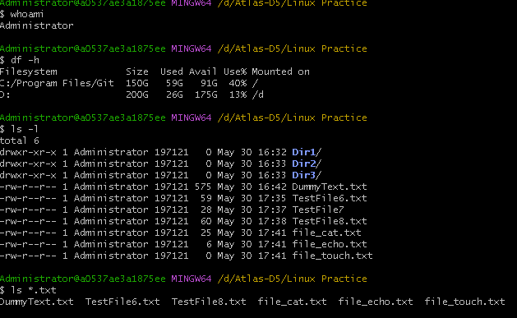

**Task 26:**

Administrator@a0537ae3a1875ee MINGW64 /d/Atlas-D5/Linux Practice

$ ls -a

./ Dir1/ Dir3/ Pr1.txt Pr3.txt file_cat.txt file_touch.txt regularfile.txt

../ Dir2/ DummyText.txt Pr2.txt TestFile7 file_echo.txt myfile2.txt symlinkfile.txt

**Task 27:**

Difference between . and .. in Linux:

* . refers to the current directory.
* .. refers to the parent directory (one level up).

**Task 28:**

Administrator@a0537ae3a1875ee MINGW64 /d/Atlas-D5/Linux Practice $ vi myfile1.txt

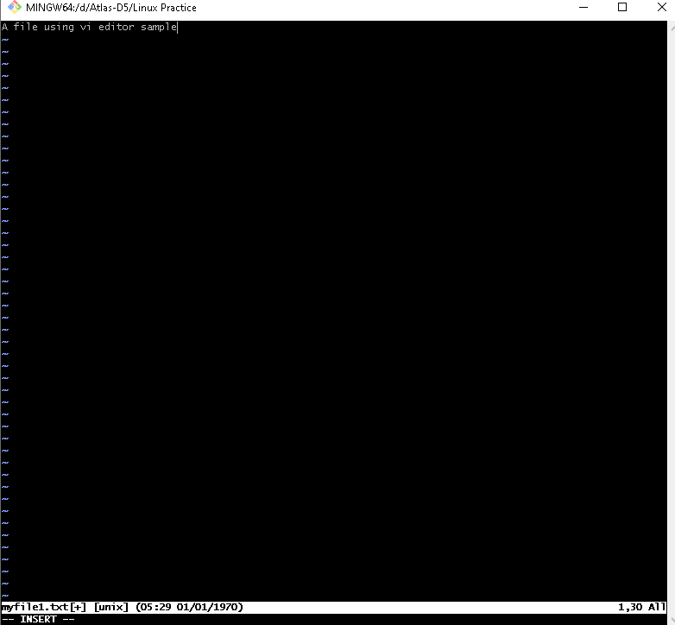

**Task 29:**

Administrator@a0537ae3a1875ee MINGW64 /d/Atlas-D5/Linux Practice

$ wc TestFile{5..8}.txt

wc: TestFile5.txt: No such file or directory

9 14 59 TestFile6.txt

wc: TestFile7.txt: No such file or directory

1 6 30 TestFile8.txt

10 20 89 total

**Task 30:**

It displays the contents of the file **with line numbers**, but **only for non-blank lines**.

Administrator@a0537ae3a1875ee MINGW64 /d/Atlas-D5/Linux Practice

$ cat -b myfile1.txt

1. A file using vi editor sample

**Task 31:**

Can I use the wc with 2 or more files? (Yes) here is how we can do it

Administrator@a0537ae3a1875ee MINGW64 /d/Atlas-D5/Linux Practice

$ wc TestFile{5..8}.txt

wc: TestFile5.txt: No such file or directory

9 14 59 TestFile6.txt

wc: TestFile7.txt: No such file or directory

1 6 30 TestFile8.txt

10 20 89 total

**Task 32:**

Administrator@a0537ae3a1875ee MINGW64 /d/Atlas-D5/Linux Practice

$ cp myfile1.txt TestFile8.txt

**Task 33:**

Now I want to rename my file with MYFILENEW can i do that if so how ?

Administrator@a0537ae3a1875ee MINGW64 /d/Atlas-D5/Linux Practice

$ mv myfile1.txt myfile2.txt